**Terraform Project**

**Create below infra using terraform**

1. **Create two virtual machines in east us (web servers)**
2. **Configure load balancer for above servers.**

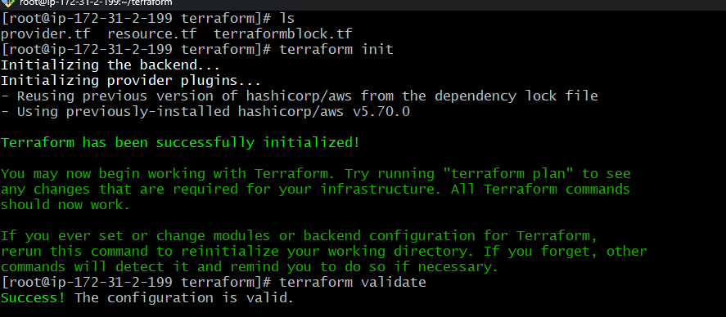

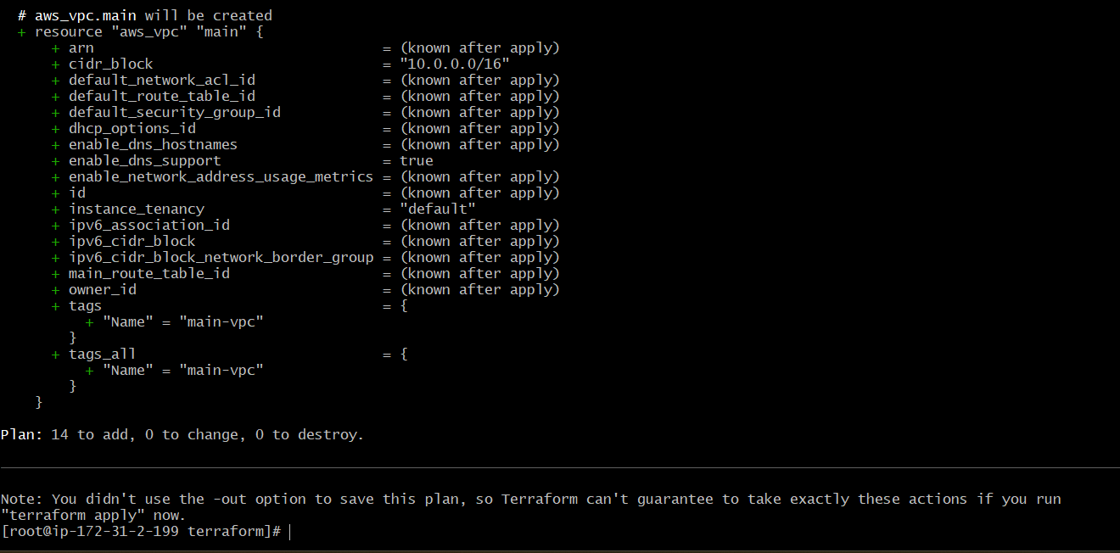

**VPC**

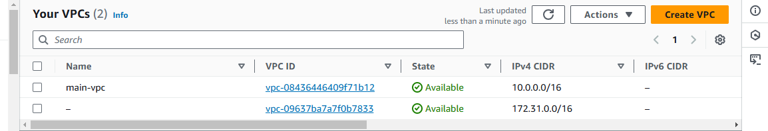

**SUBNETS**

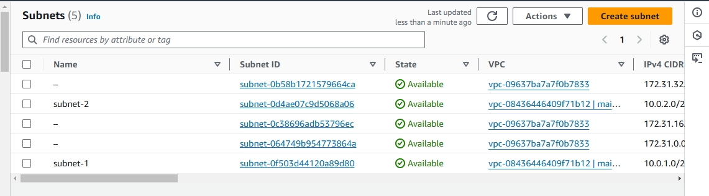

**ROUTE TABLES**

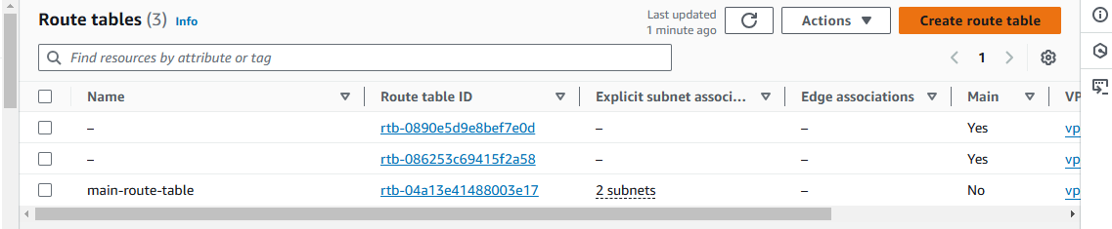

**INTERNET GATEWAY**

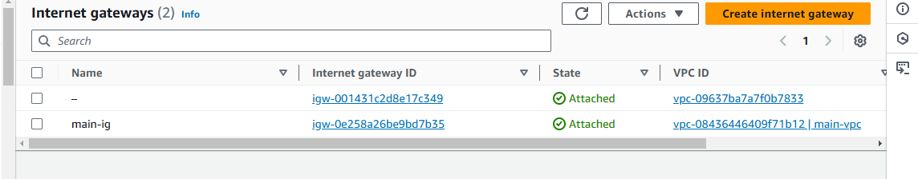

**TARGET GROPUS**

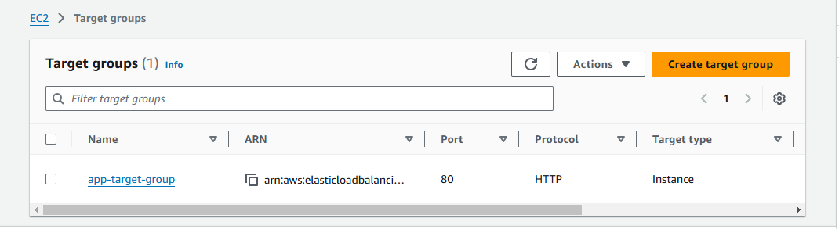

**RDS**

